**Sales For SPA**

**1. How It Works (Architecture & Workflow)**

**a. Technologies & Frameworks**

* **SharePoint Framework (SPFx)** – Used for building client-side web parts for SharePoint and Microsoft 365
* **React** – UI library for building the SPA components
* **@pnp/sp** – Fluent API for SharePoint data operations
* **Microsoft Graph** – For accessing data about users, groups, etc.

**b. Initialization & Context**

* The main entry is SalesWebPart.ts, which initializes the SPA as a SharePoint web part.
* The web part passes SharePoint context and the SPFI instance (from PnPjs) into the main component (Sales.tsx).

**c. Data Flow**

* Data is primarily managed via SharePoint Lists, accessed/modified using PnPjs (spfi().using(SPFx(this.context))).
* CRUD operations (Create, Read, Update, Delete) are performed on these lists based on user actions (e.g., submitting a form to create a sale, updating a PO, etc.).

**2. Main Methods and Components**

**a. Key React Components**

* **Sales.tsx** – Main component handling the SPA logic, state, and rendering views for Opportunities, Quotations, and Purchase Orders.
* **ViewOpportunities/ViewOpportunies.tsx** – Component for viewing opportunities.
* **ViewQuotation/ViewQuotation.tsx** – Component for viewing quotations.
* **VIewPO/ViewPO.tsx** – Component for viewing purchase orders.

**b. Methods & Utilities**

* **componentDidMount / onInit** – Lifecycle hooks for initializing context, SPFI, fetching initial data.
* **removeLineItem(index)** – Removes a line item from a sales entry.
* **fetchAllPOs** – Retrieves all Purchase Orders from the SharePoint list.
* **createList / OEMcreateList / ConfigcreateList** – Methods to create SharePoint lists if they do not exist.
* **getColumns / getConfiguredColumns** – Methods to define and configure columns for list views.
* **updateColumns** – Updates which columns are visible in PO views.
* **logAuditEntry** – Adds an audit log entry in the SharePoint list.
* **CRUD operations** – Using PnPjs to add, update, or fetch list items:

**3. SharePoint Lists and Column Names**

The SPA uses several SharePoint lists, each with specific columns. Below are the main lists and typical columns (some programmatically added):

**a. CWSalesRecords**

* **Purpose:** Stores main sales data, including opportunities, quotations, and purchase orders.
* **Columns:**
  + OpportunityID
  + POID, POID2, ..., POID5
  + POReceivedDate, POReceivedDate2, ..., POReceivedDate5
  + CustomerPONumber, CustomerPONumber2, ..., CustomerPONumber5
  + QuoteID, QuoteID2, ..., QuoteID5
  + POStatus, POStatus2, ..., POStatus5
  + AmountEUR, AmountEUR2, ..., AmountEUR5
  + Currency, Currency2, ..., Currency5
  + LineItemsJSON, LineItemsJSON2, ..., LineItemsJSON5
  + POComments, POComments2, ..., POComments5
  + ParentPOID, ParentPOID2, ..., ParentPOID5
  + POValue, POValue2, ..., POValue5
  + (Many columns have numbered variants up to 5, supporting multiple records per opportunity.)

|  |  |  |
| --- | --- | --- |
| **Display Name** | **Internal Name** | **Type** |
| OpportunityID | OpportunityID | Single line of text |
| QuoteID | QuoteID | Single line of text |
| QuoteID2 | QuoteID2 | Single line of text |
| QuoteID3 | QuoteID3 | Single line of text |
| QuoteID4 | QuoteID4 | Single line of text |
| QuoteID5 | QuoteID5 | Single line of text |
| POID | POID | Single line of text |
| POID2 | POID2 | Single line of text |
| POID3 | POID3 | Single line of text |
| POID4 | POID4 | Single line of text |
| POID5 | POID5 | Single line of text |
| Business | Business | Single line of text |
| BusinessUnit | BusinessUnit | Single line of text |
| OEM | OEM | Single line of text |
| KeyContact | KeyContact | Single line of text |
| DecisionMaker | DecisionMaker | Single line of text |
| Customer | Customer | Single line of text |
| Status | Status | Single line of text |
| EndCustomer | EndCustomer | Single line of text |
| QuoteBusinessSize | QuoteBusinessSize | Choice |
| QuoteBusinessSize2 | QuoteBusinessSize2 | Choice |
| QuoteBusinessSize3 | QuoteBusinessSize3 | Choice |
| QuoteBusinessSize4 | QuoteBusinessSize4 | Choice |
| QuoteBusinessSize5 | QuoteBusinessSize5 | Choice |
| ReportDate | ReportDate | Date and Time |
| TentativeStartDate | TentativeStartDate | Date and Time |
| TentativeDecisionDate | TentativeDecisionDate | Date and Time |
| QuoteTentativeDecisionDate | QuoteTentativeDecisionDate | Date and Time |
| QuoteTentativeDecisionDate2 | QuoteTentativeDecisionDate2 | Date and Time |
| QuoteTentativeDecisionDate3 | QuoteTentativeDecisionDate3 | Date and Time |
| QuoteTentativeDecisionDate4 | QuoteTentativeDecisionDate4 | Date and Time |
| QuoteTentativeDecisionDate5 | QuoteTentativeDecisionDate5 | Date and Time |
| QuoteDate | QuoteDate | Date and Time |
| QuoteDate2 | QuoteDate2 | Date and Time |
| QuoteDate3 | QuoteDate3 | Date and Time |
| QuoteDate4 | QuoteDate4 | Date and Time |
| QuoteDate5 | QuoteDate5 | Date and Time |
| QuoteRevisionNumber | QuoteRevisionNumber | Number |
| QuoteRevisionNumber2 | QuoteRevisionNumber2 | Number |
| QuoteRevisionNumber3 | QuoteRevisionNumber3 | Number |
| QuoteRevisionNumber4 | QuoteRevisionNumber4 | Number |
| QuoteRevisionNumber5 | QuoteRevisionNumber5 | Number |
| OppAmount | OppAmount | Number |
| OppAmount2 | OppAmount2 | Number |
| OppAmount3 | OppAmount3 | Number |
| OppAmount4 | OppAmount4 | Number |
| OppAmount5 | OppAmount5 | Number |
| QuoteAmount | QuoteAmount | Number |
| QuoteAmount2 | QuoteAmount2 | Number |
| QuoteAmount3 | QuoteAmount3 | Number |
| QuoteAmount4 | QuoteAmount4 | Number |
| QuoteAmount5 | QuoteAmount5 | Number |
| POAmount | POAmount | Number |
| POAmount2 | POAmount2 | Number |
| POAmount3 | POAmount3 | Number |
| POAmount4 | POAmount4 | Number |
| POAmount5 | POAmount5 | Number |
| POValue | POValue | Number |
| POValue2 | POValue2 | Number |
| POValue3 | POValue3 | Number |
| POValue4 | POValue4 | Number |
| POValue5 | POValue5 | Number |
| POQuoteID | POQuoteID | Single line of text |
| POQuoteID2 | POQuoteID2 | Single line of text |
| POQuoteID3 | POQuoteID3 | Single line of text |
| POQuoteID4 | POQuoteID4 | Single line of text |
| POQuoteID5 | POQuoteID5 | Single line of text |
| QuoteReceivedDate1 | QuoteReceivedDate1 | Date and Time |
| QuoteReceivedDate | QuoteReceivedDate | Date and Time |
| QuoteReceivedDate2 | QuoteReceivedDate2 | Date and Time |
| QuoteReceivedDate3 | QuoteReceivedDate3 | Date and Time |
| QuoteReceivedDate4 | QuoteReceivedDate4 | Date and Time |
| QuoteReceivedDate5 | QuoteReceivedDate5 | Date and Time |
| POReceivedDate | POReceivedDate | Date and Time |
| POReceivedDate2 | POReceivedDate2 | Date and Time |
| POReceivedDate3 | POReceivedDate3 | Date and Time |
| POReceivedDate4 | POReceivedDate4 | Date and Time |
| POReceivedDate5 | POReceivedDate5 | Date and Time |
| POStatus | POStatus | Choice |
| POStatus2 | POStatus2 | Choice |
| POStatus3 | POStatus3 | Choice |
| POStatus4 | POStatus4 | Choice |
| POStatus5 | POStatus5 | Choice |
| CustomerPONumber | CustomerPONumber | Single line of text |
| CustomerPONumber2 | CustomerPONumber2 | Single line of text |
| CustomerPONumber3 | CustomerPONumber3 | Single line of text |
| CustomerPONumber4 | CustomerPONumber4 | Single line of text |
| CustomerPONumber5 | CustomerPONumber5 | Single line of text |
| IsChildPO | IsChildPO | Yes/No |
| IsChildPO2 | IsChildPO2 | Yes/No |
| IsChildPO3 | IsChildPO3 | Yes/No |
| IsChildPO4 | IsChildPO4 | Yes/No |
| IsChildPO5 | IsChildPO5 | Yes/No |
| ParentPOID | ParentPOID | Single line of text |
| ParentPOID2 | ParentPOID2 | Single line of text |
| ParentPOID3 | ParentPOID3 | Single line of text |
| ParentPOID4 | ParentPOID4 | Single line of text |
| ParentPOID5 | ParentPOID5 | Single line of text |
| AmountEUR | AmountEUR | Currency |
| Currency | Currency | Choice |
| ConvertedAmount | ConvertedAmount | Number |
| QuoteRevenueQuoted | QuoteRevenueQuoted | Number |
| QuoteRevenueQuoted2 | QuoteRevenueQuoted2 | Number |
| QuoteRevenueQuoted3 | QuoteRevenueQuoted3 | Number |
| QuoteRevenueQuoted4 | QuoteRevenueQuoted4 | Number |
| QuoteRevenueQuoted5 | QuoteRevenueQuoted5 | Number |
| RiskLevel | RiskLevel | Choice |
| Strategic | Strategic | Choice |
| OpportunityStatus | OpportunityStatus | Choice |
| OppComments | OppComments | Multiple lines of text |
| OppComments2 | OppComments2 | Multiple lines of text |
| OppComments3 | OppComments3 | Multiple lines of text |
| OppComments4 | OppComments4 | Multiple lines of text |
| OppComments5 | OppComments5 | Multiple lines of text |
| QuoteComments | QuoteComments | Multiple lines of text |
| QuoteComments2 | QuoteComments2 | Multiple lines of text |
| QuoteComments3 | QuoteComments3 | Multiple lines of text |
| QuoteComments4 | QuoteComments4 | Multiple lines of text |
| QuoteComments5 | QuoteComments5 | Multiple lines of text |
| POComments | POComments | Multiple lines of text |
| POComments2 | POComments2 | Multiple lines of text |
| POComments3 | POComments3 | Multiple lines of text |
| POComments4 | POComments4 | Multiple lines of text |
| POComments5 | POComments5 | Multiple lines of text |
| LineItemsJSON | LineItemsJSON | Multiple lines of text |
| LineItemsJSON2 | LineItemsJSON2 | Multiple lines of text |
| LineItemsJSON3 | LineItemsJSON3 | Multiple lines of text |
| LineItemsJSON4 | LineItemsJSON4 | Multiple lines of text |
| LineItemsJSON5 | LineItemsJSON5 | Multiple lines of text |

**b. CWSalesKeyContact**

* **Purpose:** Stores key contact info for sales.
* **Columns:** Typical contact fields (see code for dynamic fields).

|  |  |  |
| --- | --- | --- |
| **Display Name** | **Internal Name** | **Type** |
| Customer | Customer | Single line of text |
| Contact | Contact | Single line of text |
| Email | Email | Single line of text |
| Address | Address | Single line of text |
| City | City | Single line of text |
| BusinessPhone | BusinessPhone | Single line of text |
| MobileNumber | MobileNumber | Single line of text |
| Designation | Designation | Single line of text |
| Department | Department | Single line of text |

**c. CWSalesOEM**

* **Purpose:** Stores OEM (Original Equipment Manufacturer) related data.
* **Columns:** OEM (Text), and others as added in code.

|  |  |  |
| --- | --- | --- |
| **Display Name** | **Internal Name** | **Type** |
| OEM | OEM | Single line of text |

**d. CWSalesAuditLog**

* **Purpose:** Audit logging for the sales process.
* **Columns:** Timestamp, action, user, etc. (added programmatically).

|  |  |  |
| --- | --- | --- |
| **Display Name** | **Internal Name** | **Type** |
| Timestamp | Timestamp | Single line of text |
| Action | Action | Single line of text |
| OpportunityID | OpportunityID | Single line of text |
| ModifiedBy | ModifiedBy | Single line of text |
| DataSnapshot | DataSnapshot | Multiple lines of text |
| Comments | Comments | Multiple lines of text |

**e. CWSalesConfiguration**

* **Purpose:** Stores configuration settings for the SPA.
* **Columns:** Title, CurrencyFormat, and others as defined in code.

|  |  |  |
| --- | --- | --- |
| **Display Name** | **Internal Name** | **Type** |
| MultiValue | MultiValue | Multiple lines of text |
| DefaultCurrency | DefaultCurrency | Single line of text |
| Value | Value | Single line of text |

**f. CWSalesCustomer**

**Purpose:** The CWSalesCustomer SharePoint list is used to store master data about customers in your sales application. This allows you to maintain a list of all customers with their relevant details, which can then be referenced across opportunities, quotations, and other sales records.

|  |  |  |
| --- | --- | --- |
| **Display Name** | **Internal Name** | **Type** |
| Customer | Customer | Single line of text |
| PersonResponsible | PersonResponsible | Person or Group |
| City | City | Single line of text |

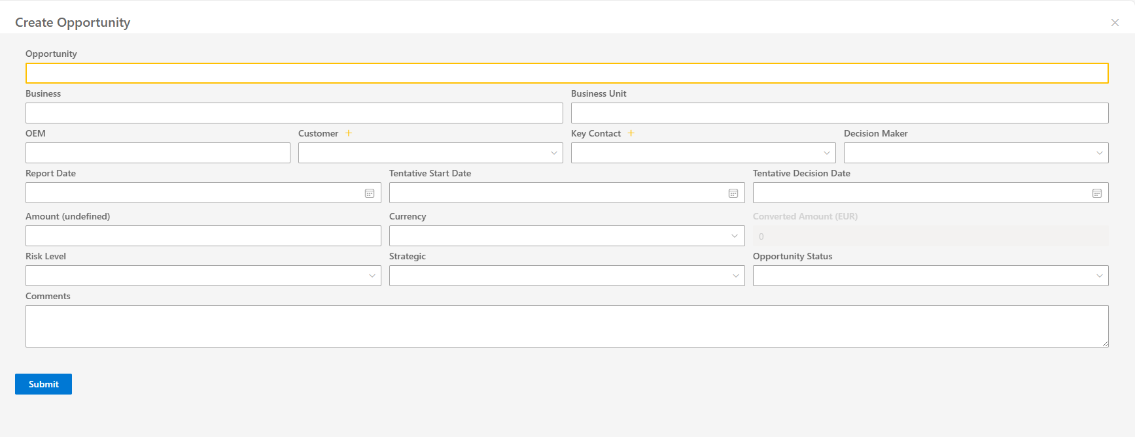

**Working of Add Opportunity:**

**1. OpportunityID (Auto-Generated)**

* **Setup:**
  + ✅ Automatically generated using format like OPP-2025-0001.
  + ✅ Uses SharePoint list (CWSalesConfiguration) for prefix (OPP).
  + ✅ Auto-increments by fetching latest entry from CWSalesRecords.
  + ✅ Field shown in UI as **read-only**.
  + 📝 Logic in method: generateNextOpportunityID().

**2. Business & Business Unit Dropdowns**

* **Business Dropdown**:
  + Create a static list of businesses (e.g., "Healthcare", "Automotive").
* **Business Unit Dropdown**:
  + Configure dynamic filtering based on the selected **Business** (e.g., selecting "Healthcare" shows units like "Pharma", "Medical Devices").
  + Use cascading/dependent dropdown logic.

**3. OEM & End Customer Dropdowns (Dynamic)**

* **Setup:**
  + ❌ Currently OEM is a plain TextField.
  + 🚫 No option to "+ Add New" or store new values.

• 📝 Backend storage in SharePoint lists not connected.

• 🔧 To be implemented as dynamic dropdowns with optional add-new logic.

**4. Customer, Key Contact, & Decision Maker**

* **Customer Dropdown:**
  + ✅ Populated dynamically from CWSalesCustomer list.
  + ✅ Option to add a new customer using the “+ Add” icon (opens panel).
* **Auto-Populate Fields:**
  + ❌ Not yet implemented.
  + 🚫 Key Contact and Decision Maker are not auto-filled based on customer.
* **Manual Override:**
  + ✅ Both fields are editable via dropdown or text input.

**5. Date Fields**

* ✅ Three DatePicker fields implemented:
  1. **Report Date** (defaults to today).
  2. **Tentative Start Date**
  3. **Tentative Decision Date**
* 📝 Format is configurable via CWSalesConfiguration ("DD-MMM-YYYY").

**6. Currency Conversion**

* **Amount Field:**
  + ✅ Labeled as Amount (EUR) by default.
  + ✅ Stores OppAmount field in SharePoint.
* **Currency Dropdown:**
  + ✅ Dropdown with dynamic values (EUR, USD, GBP).
  + ✅ Based on CWSalesConfiguration rates.
* **Conversion Logic:**
  + ✅ Converts entered amount into base currency (EUR).
  + ✅ Displays converted value in **read-only** field.
  + 📝 Uses convertToDefaultCurrency() function.

**7. Additional Dropdowns**

* ✅ Static dropdowns created for:
  + **Risk Level:** Low, Medium, High.
  + **Strategic:** Yes, No.
  + **Opportunity Status:** Open, Won, Lost, On Hold.

**8. Comments Field**

* ✅ Multi-line text box labeled **"Comments"** (field: OppComments).
* ✅ Free-form input accepted.

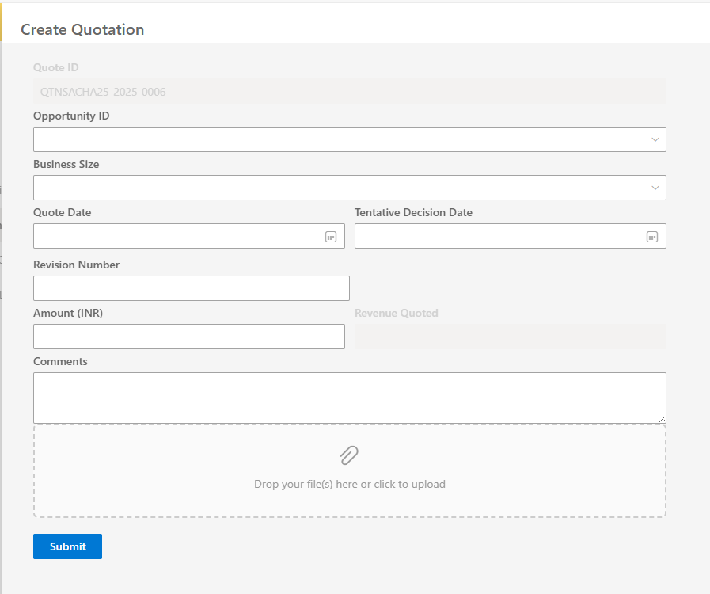

**Working of Current “Add Quotation”**

**1. Quotation ID (Auto-Generated)**

* **Setup:**
  + ✅ Automatically generated as QTN-2025-0001 using generateNextQuoteID() function.
  + ✅ Prefix (QTN) and year pulled from SharePoint config (CWSalesConfiguration → QTNConfig).
  + ✅ Quotation ID field is **read-only** in the UI form.

**2. Opportunity ID Dropdown**

* **Setup:**
  + ✅ Populated dynamically from CWSalesRecords list.
  + ✅ Allows selecting an opportunity (Title) for linking.
  + ❌ No inline “+ Add Opportunity” here (Opportunity must exist first).

**3. Business Size Dropdown**

* **Setup:**
  + ✅ Static dropdown options: Small, Medium, Large.
  + ✅ Shown on form as standard Dropdown.

**4. Quotation Dates**

* ✅ Two DatePicker fields implemented:
  1. **Quote Date**
  2. **Tentative Decision Date**
* 📝 Format is fetched from SharePoint config (DateFormat) and applied using formatDate() function.

**5. Revision Number**

* ✅ Input as a text field.
* ✅ User can manually enter revision info (e.g., Rev1, Rev2).

**6. Amount & Revenue Quoted**

* **Amount Field:**
  + ✅ Entered manually (defaults to system base currency like EUR).
* **Currency Setup:**
  + ✅ Exchange rates and default currency pulled from SharePoint (CWSalesConfiguration → Currency).
  + ❌ Currency dropdown not shown (single currency base logic applied).
* **Conversion Logic:**
  + ✅ Auto-converts QuoteAmount into revenue using selected opportunity’s currency.
  + ✅ Result shown in **read-only** "Revenue Quoted" field.
  + 📝 Uses exchangeRates, QuoteAmount × rate calculation.

**7. Comments Field**

* ✅ Multiline text field labeled “Comments”.
* ✅ Supports free-form input (stored in QuoteComments).

**8. Attachment Support**

* ✅ File uploads via DropZoneUploader.
* ✅ File stored in: Shared Documents/<OpportunityTitle>/<QuoteID>/.
* ✅ Existing attachments listed with **preview** and **delete** options.
* ✅ Supports editing/deleting individual files using SharePoint API.
* 📝 Uses loadOpportunityFiles, deleteFileFromLibrary.

**9. Save/Update Logic**

* ✅ Quotation fields stored inside existing Opportunity item (CWSalesRecords) in 5 slots (QuoteID, QuoteID2, …).
* ✅ Checks if the QuoteID already exists → Updates in-place.
* ✅ If not found → Adds to first available slot.
* ✅ Data saved using PnPjs .update().
* ✅ Logs audit entry to CWSalesAuditLog.

**10. Delete Quotation**

* ✅ Deletes all fields related to a matching QuoteID in one of the 5 slots.
* ✅ Alerts and confirms before delete.
* ✅ Updates SharePoint list item and refreshes list.

**Working of Current “Add Purchase Order (PO)”**

**1. PO ID (Auto-Generated)**

* **Setup:**
  + **✅ Auto-generated format like PO-2025-0001.**
  + **✅ Pulled from SharePoint config (CWSalesConfiguration → POConfig).**
  + **✅ Ensures uniqueness by checking all POID slots in CWSalesRecords.**
  + **✅ Displayed in the form as read-only.**
  + **📝 Logic handled in generateNextPOID().**

**2. Opportunity & Quote ID Dropdowns**

* **Opportunity Dropdown:**
  + **✅ Populated dynamically from CWSalesRecords → Title.**
  + **✅ Required for form submission.**
* **Quote ID Dropdown:**
  + **✅ Populated based on selected opportunity (up to 5 QuoteID slots).**
  + **❌ No inline “Add Quote” available.**

**3. Is Child PO & Parent PO Logic**

* **Is Child PO Dropdown:**
  + **✅ Options: Yes / No (stored as boolean).**
  + **✅ Controls if "Parent PO ID" is enabled.**
* **Parent PO ID Dropdown:**
  + **✅ Dynamically lists all existing PO IDs from SharePoint.**
  + **✅ Enabled only if "Is Child PO" is set to Yes.**

**4. PO Date & Status**

* **PO Received Date:**
  + **✅ Implemented using DatePicker.**
* **PO Status:**
  + **✅ Static dropdown: Draft, Issued, Approved, Cancelled.**

**5. PO Value & Currency Conversion**

* **PO Value Field:**
  + **✅ User enters in base currency (e.g., EUR).**
  + **✅ Uses defaultCurrency from config.**
* **Conversion Logic:**
  + **✅ Converts entered value using exchange rate from selected Opportunity’s currency.**
  + **✅ Auto-calculates and fills PO Amount.**
  + **✅ PO Amount is read-only.**

**6. Line Items**

* **✅ Users can add multiple line items, each with:**
  + **Title**
  + **Comments**
  + **Value**
* **✅ Items are stored as JSON (LineItemsJSON) in SharePoint field.**
* **✅ Line items editable during PO editing.**
* **✅ Remove button for each line item is present.**

**7. Comments Field**

* **✅ Multiline text field for “PO Comments”.**
* **✅ Stored in POComments field.**

**8. Attachments (PO Files)**

* **✅ Uses DropZoneUploader for file selection.**
* **✅ Files uploaded to:**

**php-template**

**CopyEdit**

**Shared Documents/<OpportunityID>/<POQuoteID>/<POID>**

* **✅ Uploaded using PnPjs .files.addUsingPath().**
* **✅ Existing files shown with:**
  + **Preview option**
  + **Delete option (moves file to recycle bin)**

**9. Save/Update PO**

* **✅ Saves PO in one of 5 slots in CWSalesRecords (POID, POID2...).**
* **✅ If existing PO ID found → Update slot.**
* **✅ If not → fills first empty PO slot.**
* **✅ Saves related fields:**
  + **Quote ID**
  + **Status**
  + **Value**
  + **Currency**
  + **Line items**
  + **Comments**
* **✅ Logs action to CWSalesAuditLog.**

**10. Delete PO**

* **✅ Deletes data from the matching slot in CWSalesRecords.**
* **✅ Prompts user for confirmation.**
* **✅ Does not delete attachments, only metadata.**

**11. Column View Customization**

* **✅ Users can edit visible columns using "Edit Columns" panel.**
* **✅ Preferences stored in localStorage (editPOItem).**

**12. PO List & Search**

* **✅ Searchable by:**
  + **PO ID**
  + **Opportunity ID**
  + **PO Status**
  + **Customer PO Number**
* **✅ Paginated list with Previous/Next buttons.**
* **✅ Excel export feature using xlsx library.**